|  |
| --- |
|  |
| Capstone Project Document |

**Vietnamese Medicinal plant Network**

Report #1 - User Requirement Specification

|  |  |  |
| --- | --- | --- |
| **Dandelion** | | |
| **Group Members** | Nguyễn Minh Tiến | SE02545 |
| Hoàng Thị Quỳnh | SE02639 |
| Trần Bình Khánh | SE02764 |
| Nguyễn Hải Đăng | SE02992 |
| **Supervisor** | Mr. Nguyễn Văn Sang | |
| **Project code** | VMN | |

**- Hanoi, 09/2015 –**

# SIGNATURE PAGE

AUTHOR: Trần Bình Khánh 14/01/2015

Team member

REVIEWERS: Nguyễn Minh Tiến 15/01/2016

Project manager

APPROVAL: Nguyễn Văn Sang --/--/--16

Supervisor

Record of change

*A - Added M - Modified D – Deleted

|  |  |  |  |  |  |
| --- | --- | --- | --- | --- | --- |
| Effective Date | Changed Item | A,M,D | Change Description | Reason for Change | Rev. Number |
| 15/Jan/2016 | Create User Requirement Specification | A | First version | Create User Requirement Specification | 1.0 |
|  |  |  |  |  |  |
|  |  |  |  |  |  |
|  |  |  |  |  |  |
|  |  |  |  |  |  |
|  |  |  |  |  |  |
|  |  |  |  |  |  |
|  |  |  |  |  |  |
|  |  |  |  |  |  |
|  |  |  |  |  |  |
|  |  |  |  |  |  |
|  |  |  |  |  |  |
|  |  |  |  |  |  |
|  |  |  |  |  |  |
|  |  |  |  |  |  |
|  |  |  |  |  |  |

Table Contents

SIGNATURE PAGE 1

1 USER REQUIREMENTS SPECIFICATION 3

1.1 Introduction 3

1.1.1 Purpose 3

1.1.2 Definition and Acronyms 3

1.2 Overall Description 3

1.2.1 Business Process Overview 3

1.2.2 Product Features 16

1.2.3 User characteristic 17

1.3 Functional Requirements 18

1.3.1 Common Function 18

1.3.2 Discover Projects 18

1.3.3 Create Project 18

1.3.4 Back Project 18

1.3.5 Send/Receive messages 18

1.3.6 Management profile 18

1.3.7 Management Member’s account 19

1.3.8 Management Project 19

1.3.9 Management Dashboard Overview 19

1.4 Non-functional Requirement 19

# USER REQUIREMENTS SPECIFICATION

## Introduction

### Purpose

This document will provide the describing of general requirement and non-functional requirements of our VMN system. It also describes the requirement scope of each phase in the project.

### Definition and Acronyms

|  |  |
| --- | --- |
| Terms | Description |
| VMN | Vietnamese Medicinal plants Network |
| Article | Article about medicinal plant or Remedy |

Table 1‑1: Definition and Acronyms

## Overall Description

### Business Process Overview

VMN is a website. Therefore, that system will implement the following processes:

#### Approve/Suspend workflow

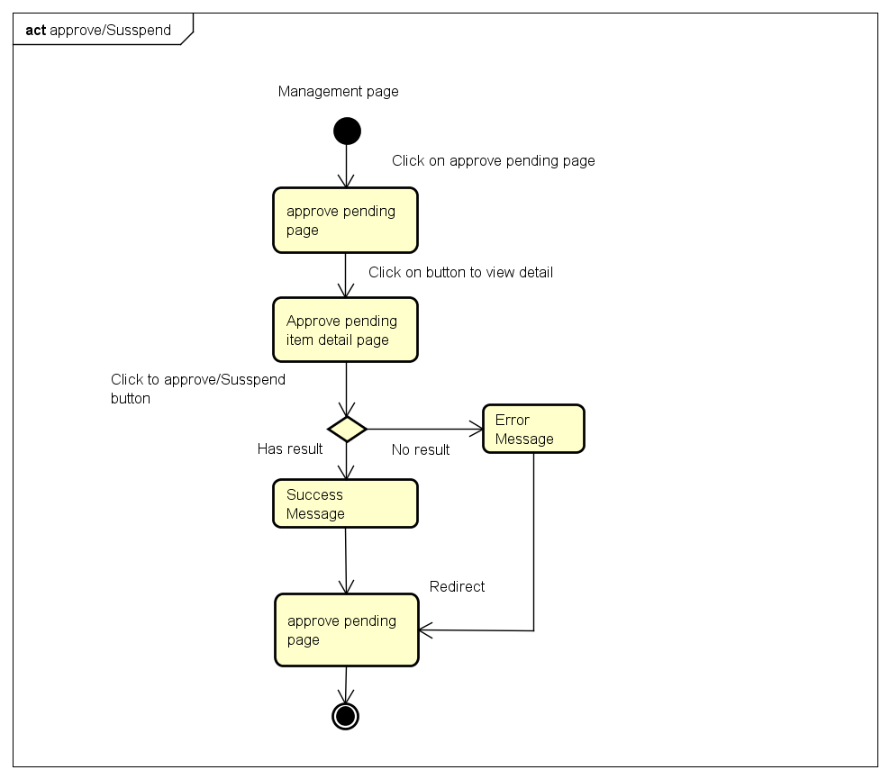

Figure 1‑1: Approve/Suspend workflow

Brief description: Admin and Mod can use this function. Steps:

* Step 1: User click on approve pend list.
* Step 2: System return projects list page.
* Step 3: User click on button view
* Step 4: System return project detail page.
* Step 5: User click on button Approved/Suspended
* Step 6: System return success message or error message.
* Step 7: System return projects list page.

#### Active/Inactive workflow

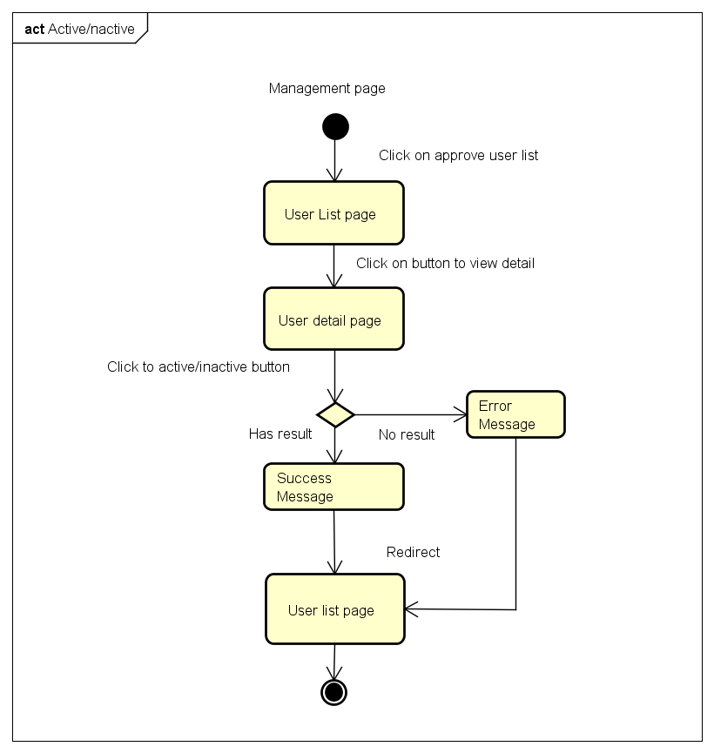

Figure 1‑2: Active/Inactive workflow

Brief description: Admin can use this function. Steps:

* Step 1: User click on users list.
* Step 2: System return users list page.
* Step 3: User click on button view a user
* Step 4: System return user profile page.
* Step 5: User click on button Active/Inactive
* Step 6: System return success message or error message.
* Step 7: System return users list page.

#### Register workflow

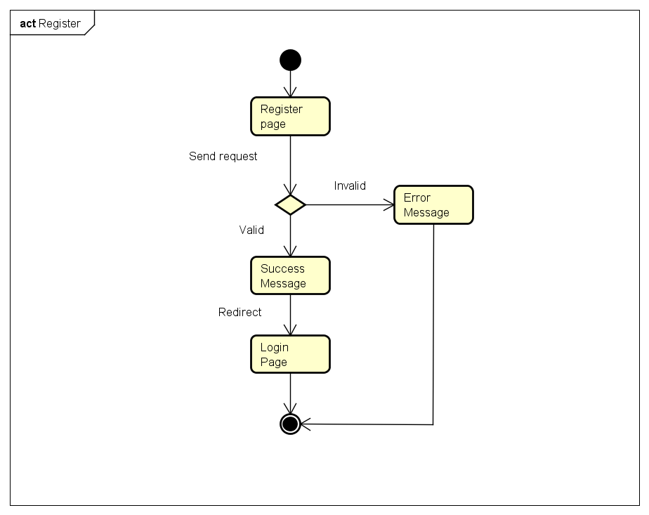

Brief description: Guest can use this function. Steps:

* Step 1: User click register.
* Step 2: System return register page.
* Step 3: User fill all required fields and click Register or press Enter.
* Step 4: System return complete message.
* Step 5: System redirect to Login page

#### Add Medicinal Plant workflow

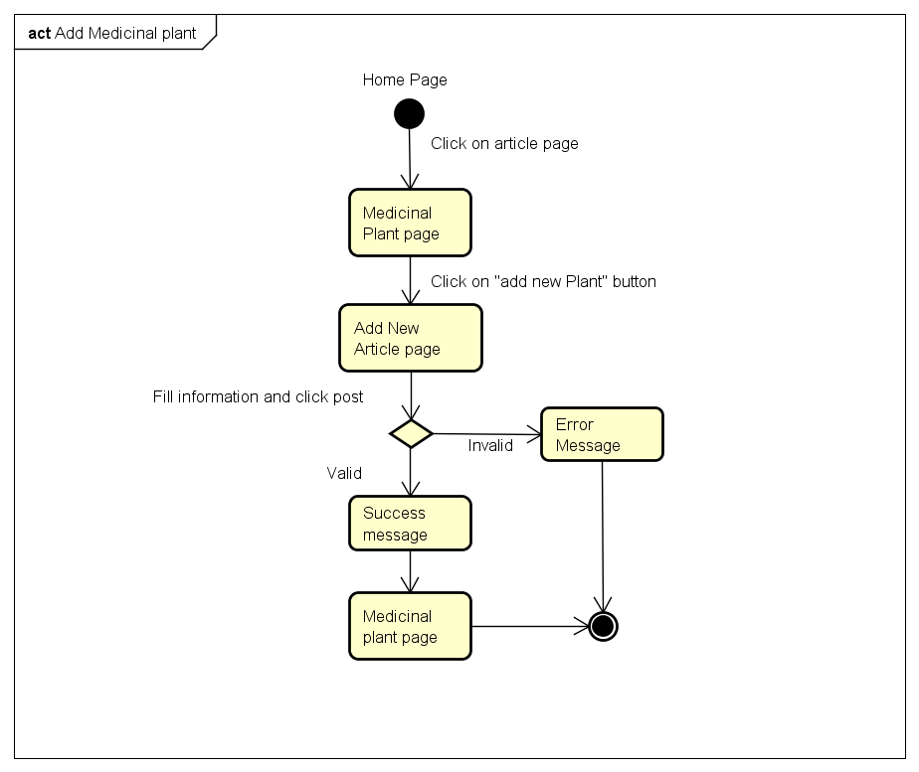

Brief description: Admin can use this function. Steps:

* Step 1: User click on Medicinal plant page.
* Step 2: System return Medicinal plant page.
* Step 3: User click on button new article
* Step 4: System return “Add Medicinal plant Category” page.
* Step 5: User fill information and click “Post”
* Step 6: System return success message or error message.
* Step 7: System return Medicinal plant page.

#### Add Remedy workflow

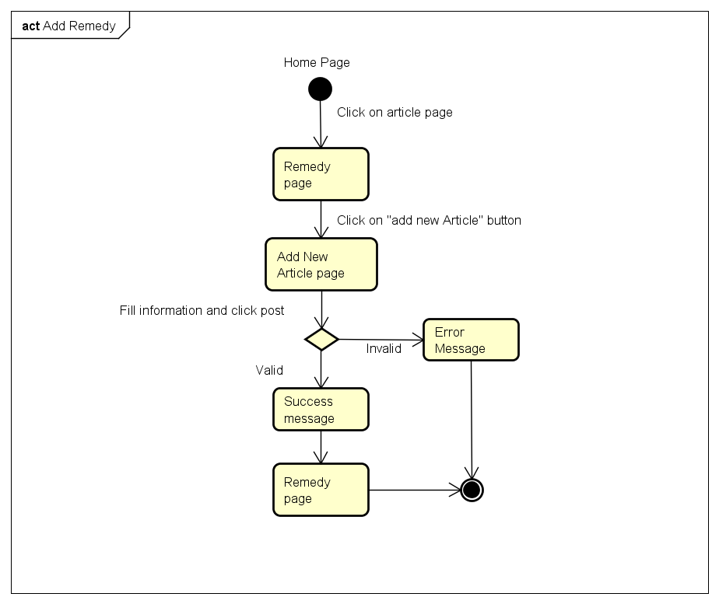

Brief description: Admin can use this function. Steps:

* Step 1: User click on Remedy.
* Step 2: System return remedy page.
* Step 3: User click on button new article.
* Step 4: System return dialog “Add New Remedy”.
* Step 5: User fill information and click “Add”
* Step 6: System return success message or error message.
* Step 7: System return Remedy page.

#### Rating workflow

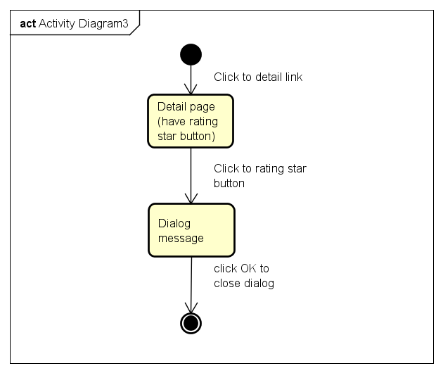

Brief description: Member or Mod can use this function. Steps:

* Step 1: User click on Article detail (Medicinal plant or Remedy detail).
* Step 2: System return detail page.
* Step 3: User click on “rating star” button.
* Step 4: System return dialog “Thank for rating”.
* Step 5: User click “OK” button
* Step 6: System close dialog

#### Search workflow

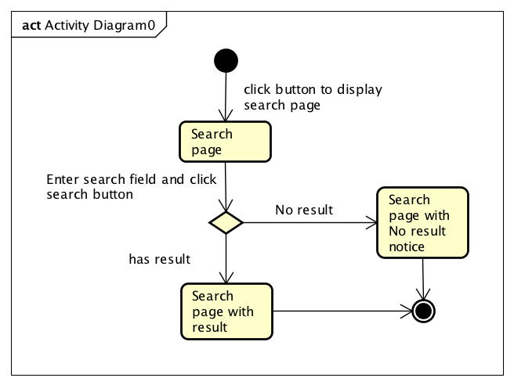

Figure 1‑6: Search workflow

Brief description: Guest and Member can use this function. Steps:

* Step 1: User click button to show search page
* Step 2: System display search results or message if nothing found.
* Step 3: User input keyword into search text box and click Search or press Enter
* Step 4: System display search results or message if nothing found.

#### Comment workflow

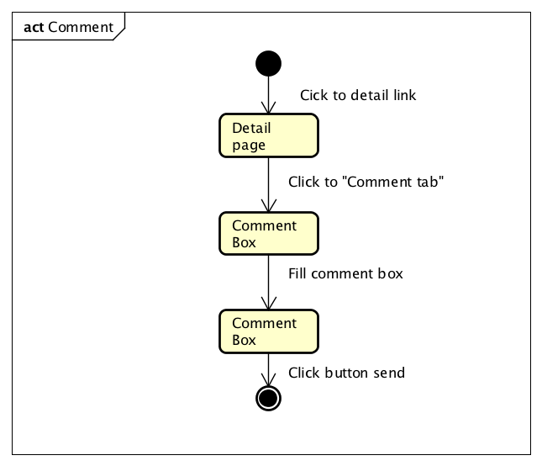

Figure 1‑7: Comment workflow

Brief description: Member can use this function. Steps:

* Step 1: User click on a project.
* Step 2: System return Project information page.
* Step 3: User click on comment tab.
* Step 4: System show comment tab.
* Step 5: User fill comment box.
* Step 6: User click sent.

#### Report an article workflow

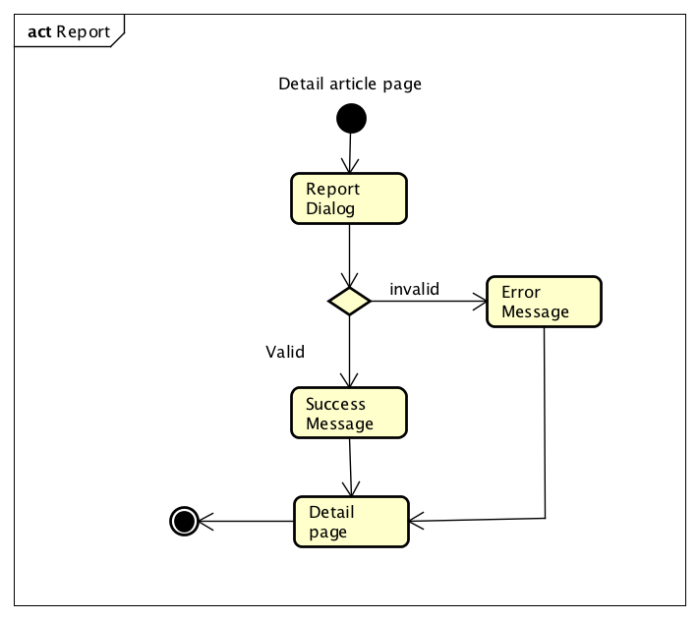

Figure 1‑11: Report a project workflow

Brief description: Member can use this function. Steps:

* Step 1: User click on report button.
* Step 2: System return “Report project” dialog.
* Step 3: User fill information and click “Sent”
* Step 4: System return success message or error message.
* Step 5: System return project detail page.

#### Remind a project workflow

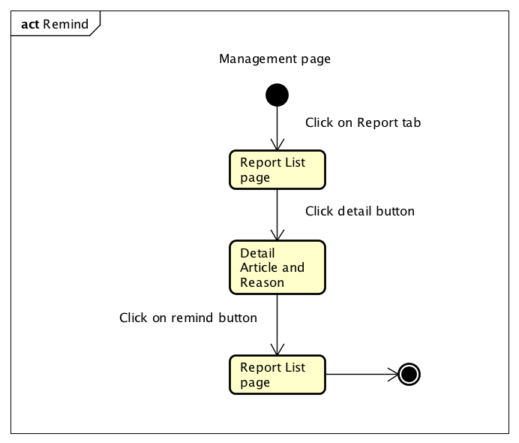

Figure 1‑8: Remind a project workflow

Brief description: Mod can use this function. Steps:

* Step 1: Mod click on “Report tab” button.
* Step 2: System display report list
* Step 3: Mod click on detail button.
* Step 4: System display detail “Article and report’s reason” page
* Step 5: Mod click to Remind button
* Step 6: System send a remind message to Article contributor and display Report list page

### Product Features

VMN is a website, user only connect to Internet to use website. System provides these main functions:

#### Member features

* Register: Guest can register an account and login to use features of VMN system.
* Login/Logout/Forgot password: Member can login/logout an account to use or exit system project. If member forgot password, they can reset their password again by email.
* Search:
* Basic Search: Search by name: member can search a medicinal plant at medicinal plant tab, a remedy at remedy tab by name.
* Advance search: Search by utility, allocation place, characteristics… or multiple conditions: member can search by utility, allocation place, characteristics or multiple conditions of medicinal plants or remedies and system will display result as a list which suitable with key words.
* A medicinal plant article:
* Contribution: Member can contribution a new article of medicinal plants with basic info such as: name, utility, allocation place, science name …
* Change content: Member can edit and update their medicinal plant articles but they have to wait of Mod’s approving.
* Comment/Rate: Member can comment/rate a medicinal plant article.
* Report: Member can report a medicinal plant article when it has problem as duplicate, wrong information… to Mod.
* Share/ Like: Member can share a medicinal plant article through facebook.
* A remedy article:
* Contribution: Member can contribution a new article of remedy with basic info such as: title, utility, usage….
* Change content: Member can edit and update their remedy articles but they have to wait of Mod’s approving.
* Comment/Rate: Member can comment/rate an article.
* Report: Member can report a remedy article when it has problem as duplicate, wrong information … to Mod.
* Share/ Like: Member can share a remedy article by facebook.
* Member’s information:
* Change password: Member can change password to keep security.
* Update profile: Member can edit or update their information as name, address, avatar, ...

#### Admin features

* Manage member:
* Search user: Admin can search with name of user and system will display simple information about that user (name, email, phone number)
* Inactive/active user: admin can set user’s account to inactive or active.
* Authorization

#### Mod features

* Manage Medicinal plant article:
* Search Medicinal plant article:
* Basic search: Mod can search by name of a Medicinal plant article and system will display result as a list what suitable with key words.
* Advance search: Search with utility, allocation place, description… or multiple conditions: Mod can search by utility, allocation place, description… of medicinal plants or remedies and system will display result as a list which suitable with key words.
* Approve new Medicinal plants article: Mod can set status of a Medicinal plant article: pending to approved, pending to suspend, approved to suspend, etc.
* Approve change Medicinal plant article content: Mod has ability to approve Medicinal plant article content’s change of author.
* Add new Medicinal plants article: Mod also can contribute a new medicinal plants as a member.
* Change Medicinal plants article content: Mod can edit and update their Medicinal plants article but he/she does not need to wait for approving.
* Comment/Rate: As a member, Mod also can comment/rate an article.
* Share/ Like an article through facebook.
* Manage Remedy article:
* Search Remedy article:
* Basic search: Mod can search by name of a Remedy article and system will display result as a list which suitable with key words.
* Advance search: Search with utility, description, usage… or multiple conditions: Mod can search by utility, description, usage… of medicinal plants or remedies and system will display result as a list which suitable with key words.
* Approve new Remedy article: Mod can set status of a Remedy article: pending to approved, pending to suspend, approved to suspend, etc.
* Approve change Remedy article content: Mod has ability to approve Remedy article content’s change of author.
* Add new Remedy article: Mod also can create a new remedy as a member.
* Change Remedy article content: Mod can edit and update their Remedy article but he/she does not need to wait for approving.
* Comment/Rate: As a member, Mod also can comment/rate a Remedy article.
* Share/ Like an article through facebook.

### User characteristic

This website is a major platform for crowd funding. Anybody could launch a project on Dandelion as long as it follows our rules. We believe that creative projects making a better world, and we’re thrilled to help support new ones. Building a community of backers around an idea is an amazing way to make something new. The website requires users to have the ability to use a browser with an Internet connection. If users want to use all function, they must be login.

There are 3 main actors that system support:

* **Member:** Have account on system, they can use all functions of website. For example: Searching, add new article, comment, rate …
* **Administrator:** They are system manager. They manage all users in system. They can approve new register, active/inactive an account and up an account to mod or down to common Member
* **Mod:** They can use all member function. Moreover, they are content manager; they decide what will display in system. They receiving and processing report from member

## Functional Requirements

### View Article

**Access right: Guest and member**

This function is used to view an article. The system will display a detail page for user. In this screen, user can find useful information. If user is signed in, the can give rate, comment and report article. If the user is article contributor, that user can show edit page from detail page

### Add New Article

**Access right: Member** **and mod**

This function is used to create new article. System will display “add new page” with many information fields. By fill all required field user could post article. If the user is mod, this article will added to system’s data, if not, the article will be sent to mod for approve.

### Edit Article

**Access right: Member and Mod**

This function is used to edit article. System will display “edit article page” with many information fields. By fill all required field user could post article. If the user is mod, this change will be applied, if not, the change will be sent to mod for approve.

### Search Information

**Access right: all users.**

In search page user can find specific information by provide some keyword. If user is signed in, they can use more feature of search function.

### Review article

**Access right: Member**

This function is used to review an article. In detail page, user members can send their comment or rating point about an article. Information from reviewing activities will help to improve articles in system

### Report Article

**Access right: Member**

This function is used to send a report about article. In detail page, if user is not article’s contributor, they can send report with reason to Mod to improve article’s quality. Otherwise admin can create Mod account.

### Management Account

**Access right: Administrator**

This function is used to management account in system. The system will display a Management Screen for admin. In this screen, admin can view information about user and give decision to approve or suspend herbal medicine store’s register and active/inactive or change role of an account.

### Management content

**Access right: Mod**

This function is used to management data content. The system will display a Management Screen for mod. In this screen, mod can view information about any article (current, new, or editing). Mod can approve or ignore add new or editing request from member. Otherwise, they can delete articles.

## Non-functional Requirement

The system has to satisfy these principles:

* **Learnable**: The user interface must be easy to learn, even at the first time looking at the screen, user may immediately understand the function of each button or icon.
* **Efficiency**: The user interface must minimize the number of steps that the system takes to complete its task.
* **Memorable**: System contains some complex screens. Therefore, interface should be easier to use each time the user interacts with it.
* **Visibility**: Important information (example: text in nodes) should be clearly visible.
* **Consistency**: Like items should always be displayed and act the same way through the entire application.
* **Easy to maintain and upgrade**
* **Ensure data security capabilities, high performance**
* **Scalability systemx**